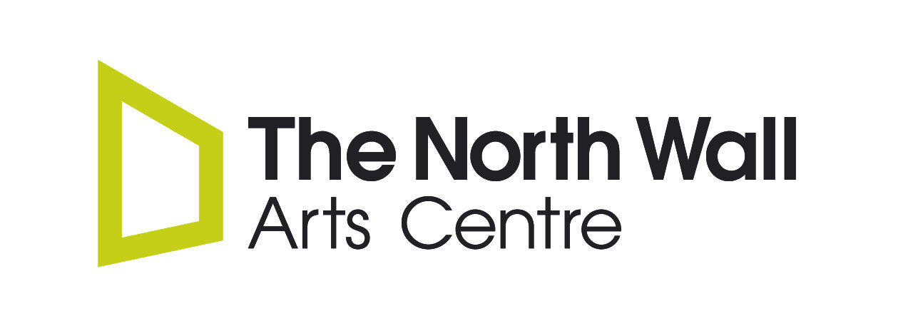Youth Board 2024 – 2025 Dates
Date | Time | Venue | Activity / Notes
2024
27th February | 4:45 – 6:00pm | The North Wall Arts Centre, OX2 7JN
12th March TBC | 4:30 – 8:00pm | The North Wall Arts Centre, OX2 7JN | Training evening & dinner
26th March | 4:45 – 6:00pm | The North Wall Arts Centre, OX2 7JN
30th April | 4:45 – 6:00pm | The North Wall Arts Centre, OX2 7JN
MAY HALF TERM BREAK | BREAK | BREAK | BREAK
25th June | 4:45 – 6:00pm | The North Wall Arts Centre, OX2 7JN
30th July | 4:45 – 6:00pm | The North Wall Arts Centre, OX2 7JN
AUGUST SUMMER BREAK | BREAK | BREAK | BREAK
24th September | 4:45 – 6:00pm | The North Wall Arts Centre, OX2 7JN
OCTOBER HALF TERM BREAK | BREAK | BREAK | BREAK
26th November | 4:45 – 6:00pm | The North Wall Arts Centre, OX2 7JN
17th December | 4:45 – 6:00pm | The North Wall Arts Centre, OX2 7JN
2025
28th January | 4:45 – 6:00pm | The North Wall Arts Centre, OX2 7JN
25th February | 4:45 – 6:00pm | The North Wall Arts Centre, OX2 7JN
25th March | 4:45 – 6:00pm | The North Wall Arts Centre, OX2 7JN
29th April | 4:45 – 6:00pm | The North Wall Arts Centre, OX2 7JN
MAY HALF TERM BREAK | BREAK | BREAK | BREAK
24th June | 4:45 – 6:00pm | The North Wall Arts Centre, OX2 7JN
29th July | 4:45 – 6:00pm | The North Wall Arts Centre, OX2 7JN

