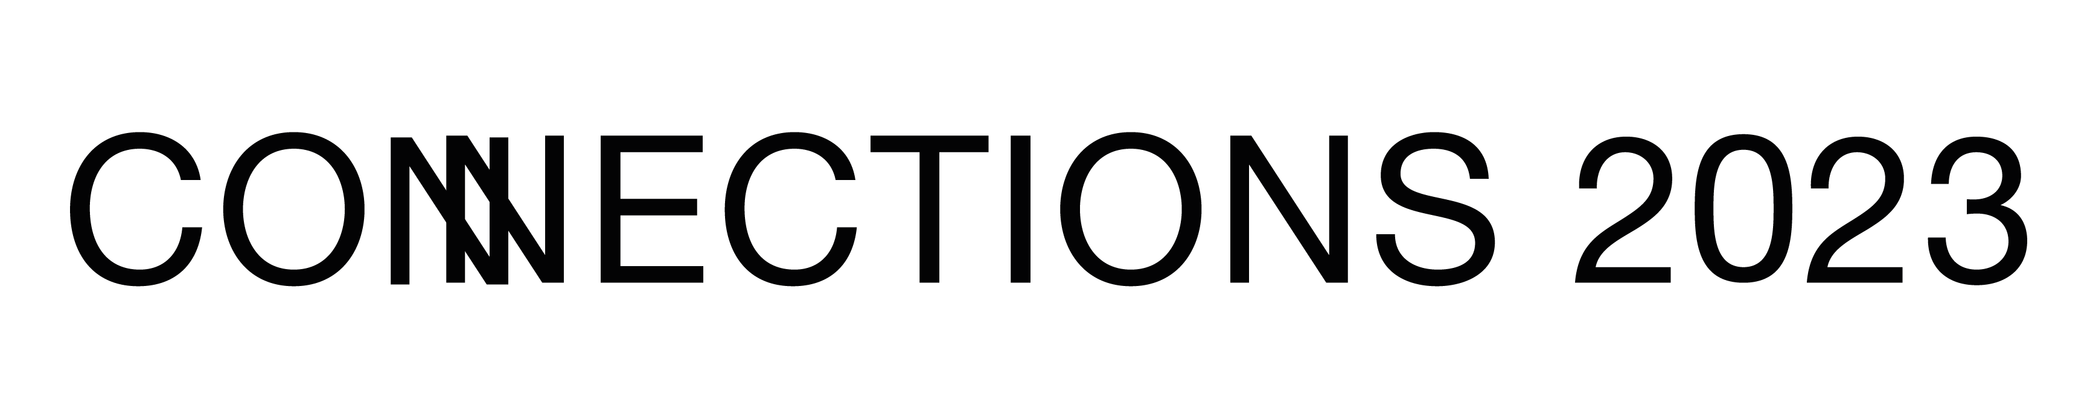

Technical Theatre Course
Application

Please read and complete the whole application

Important Information and Dates:
- Applications for the Technical Theatre Course close: 26 January 2023.
- This is an open access project; all places are free and transport costs are covered.
- This project is open to 14 – 18-year olds.
- You do not need previous experience to apply.
- You will be expected to attend:
- Zoom Intro to the project at The North Wall on 31 Jan, 4.30pm - 5pm
- Meet and Greet at The North Wall on 31 Jan, 5pm - 6.30pm
- Crash Course Workshops at The North Wall on 11 March, 10am - 4pm
- Refresher Workshop at The North Wall in April (date tbc)
- NT Connections Festival on 27 April – 30 April
- Your Technical Diaries will be due to submit on 5 May
- All workshops will be compliant with government guidelines, appropriately risk assessed and led by industry professionals.

When applying for a place on the Technical Theatre Course, we expect you to be able to commit to all dates. If you are unable to make any of the proposed dates, please let Abie know as soon as possible.

Information for Parents/Carers to complete

Your Details
- Name of Booker:
- Phone Number of Booker:
- Email Address of Booker:
- Address of Booker:

Your Child’s Details
- Name of Child:
- Child DOB:
- Medical/Health Details:
- Access Requirements:
- Additional Info:
- First emergency contact name and relationship to child
- First emergency contact phone number:
- Second emergency contact name and relationship to child:
- Second emergency contact phone number:

Permissions
- Names and phone numbers of people authorised to drop off and collect child

- I give permission for my child to sign themselves out at the end of the day and make their own way home
Yes / No

- In the event of an emergency, I give permission for First Aid to be carried out on my child by a suitably qualified adult.
Yes / No

- I give permission for The North Wall to take photographs and film footage of my child during the project, which will be used and stored for archive and documentation purposes, and may also appear in print, on websites and social media for the purposes of publicising and promoting The North Wall's work.
Yes / No

- Please add me to The North Wall’s mailing list for news about upcoming events and opportunities relevant to me.

No / Yes, I’d like receive emails/post (please delete as appropriate)

Information for applicants to complete

- Tell us about any experience you have in Technical Theatre (Don’t worry if you don’t have any experience)

- Why would you like a place on the Technical Theatre Course?

- What part of Technical Theatre interests you the most? (Lighting, Sound, Design, Stage Management etc.)

- What do you hope to get out of the project?

Thank you for taking the time to complete this application form, we will be in touch with you on Friday 27 Jan to let you know the outcome of your application.
Please email the completed form to Abie: waltona@thenorthwall.com

To read our Privacy Policy, click here: https://www.thenorthwall.com/privacy-promise/

