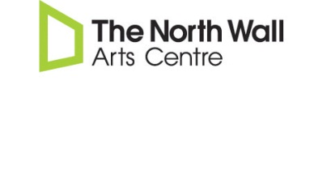
NORTH WALL THEATRE HIRE APPLICATION FORM
Please fill out this form to enable us to gauge whether the venue is available and/or suitable for your event.
Contact Name: |  |  | Tel:
E-mail: |  |  | Registered charity? |  | YES / NO
Name of Organisation (if applicable) |  |  | Address:

Does your event have a charitable purpose? YES / NO
If ‘YES’ please describe, including details of intended beneficiaries

Details of proposed event:
(including rationale, content, timings, how it is being set up and organised, technical facilities required, anticipated numbers etc.)

Catering arrangements, if relevant:
(Specifically, would you be looking to use the North Wall bar?)

Preferred dates and times:
(Please be as flexible as possible, giving a first and subsequent choices where appropriate)

Is your event open to the public? YES / NO

Will you be requiring a box office service to sell tickets for your event? YES / NO
(The North Wall retains an 8% commission on all tickets sold through our box office, except where specifically negotiated otherwise)

Would you be looking for inclusion in the North Wall brochure and/or website? YES / NO
(Only granted in exceptional circumstances)
Details

Thank you for filling out this form. Please append any further relevant information below, and then send this form to Amy Walters, Programme Manager, The North Wall, South Parade, Oxford OX2 7NN, or e-mail waltersa@thenorthwall.com We will endeavour to respond in the first instance within 2 weeks.

