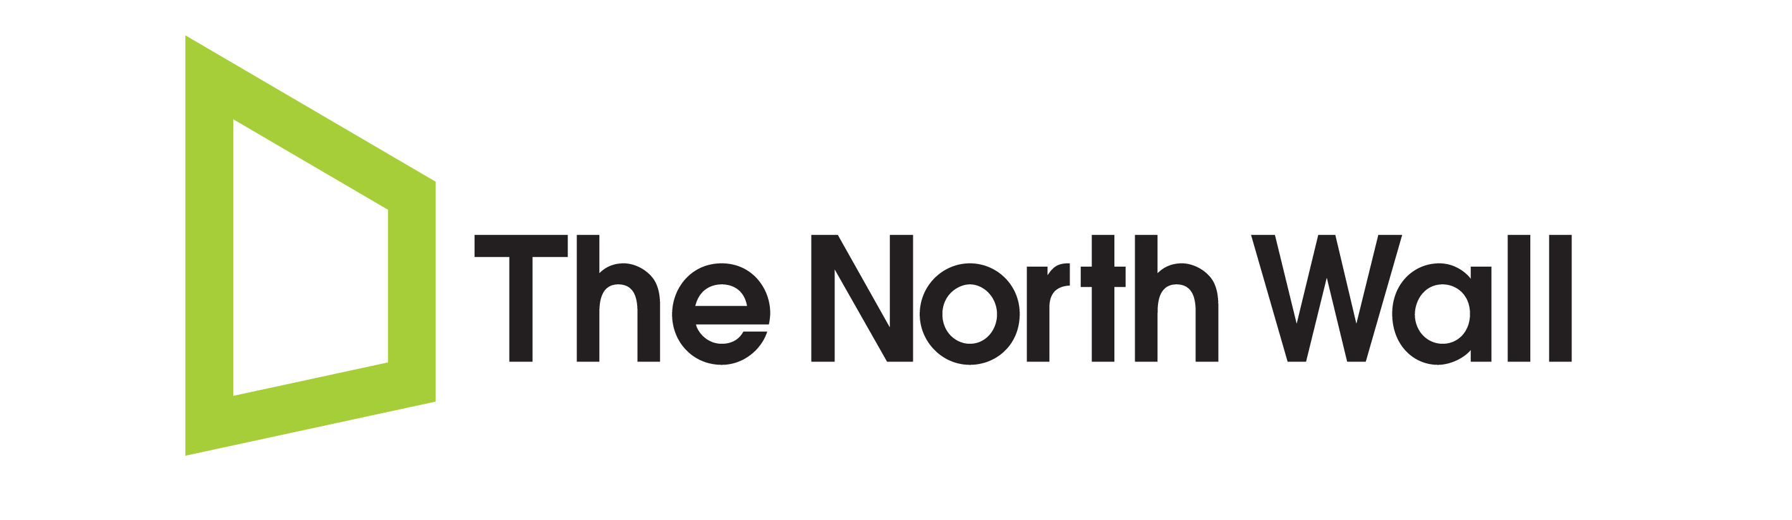
North Wall Easter ArtsLab
Application Form (DIRECTORS)
Please ensure you will be free for the duration of the project (Monday 1st April – Friday 12th April 2019) before applying. To apply, please fill in this form, attach a CV if available and (links to) any images or showreels of past productions with which you have been involved in a directorial capacity. Completed applications need to be received by 5pm on Friday 30th November 2018.

Name: Gender: Male / Female / Non-Binary
Please circle as appropriate
Date of birth: Age:
Address :

(You must be ordinarily resident in the UK at time of applying and up to and including the project dates)
Phone Number: (Landline): (Mobile):
Email:
Where did you hear about the North Wall Easter ArtsLab Residency 2019?
In approximately 400 words please use this space to discuss your influences as a director and whose work you admire.

What play(s) would you really like to direct and why? What are the qualities that make a good theatre director, and what kind of training would be the most useful?
Please continue on an additional sheet if necessary.

EDUCATION AND TRAINING (16+)
Please list any relevant theatre/arts-based courses and qualifications that you have taken or are currently taking (post GCSE). Please attach a CV if available.
Dates of Course  (mm/yy – mm/yy) | Institution | Title / Type of Course | Achievement  (if applicable)

EXPERIENCE
In approximately 250 words please briefly outline your past experience of theatre related work, including details of any relevant work experience (professional or voluntary), and any achievements before, during and after study or training.

In approximately 250 words please tell us why you want to take part in this project. What do you hope to get out of it?

THE NORTH WALL: Easter Residency 2019
Project Duration: 1st April – 12th April 2019

FOR INFORMATION: You will also be invited to stay and attend Alchymy New Plays Festival (12th – 14th April) – although this is optional, and accommodation may not be available over the weekend.

I confirm that, to the best of my knowledge, I am currently available to commit to the full dates of the project. All details and particulars I have given on this form are true, to the best of my knowledge.

Signature: _________________________________________________
(an electronic signature is fine)

Print name: _________________________________________________

Date: _________________________________________________

IMPORTANT: FOR DATA PROTECTION PURPOSES
Please note that we will store your data in order to be able to communicate with you about your application. In order for us to legally continue to inform you about ArtsLab and/or events and projects at the North Wall which we think might interest you, you will need to answer the questions below.

Please select the appropriate answer to the following statements:

I would like to receive information about future ArtsLab projects at the North Wall.
YES / NO

I would like to receive information about future events and projects at the North Wall that may be deemed relevant to me. YES / NO

Thank you!

