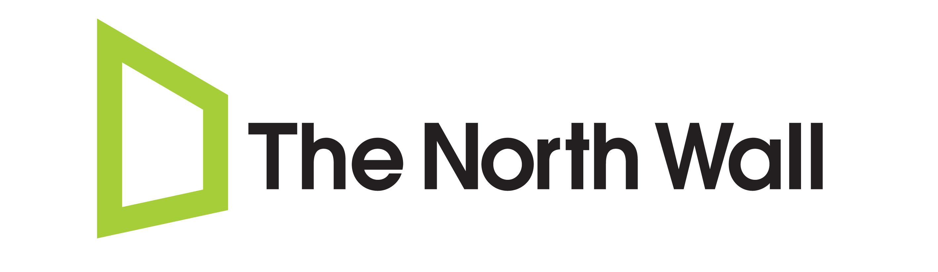
Your Photo if available
(Performers only)

North Wall Summer ArtsLab
Application Form
Please ensure you will be free for the duration of the project (Monday 23rd July – Saturday 11th August 2018) before applying. Completed applications need to be received by 5pm on Friday 18th May 2018. Please note, you must be ordinarily resident in the UK at the time of the residency.

Name: Gender: Male / Female / Non-Binary
Please circle as appropriate
Date of birth: Age:
Address :

(You must be ordinarily resident in the UK at time of applying and up to and including the project dates)
Phone Number: (Landline): (Mobile):
Email:
Please select which you are applying to do:
Acting ☐ Design ☐ Technical ☐ Music ☐ Producing ☐
If acting, select where / when you would prefer to audition:

London (Sat 9th June) ☐ Oxford (Sun 10th June) ☐ Either ☐

PLEASE NOTE: Your choice of audition day cannot be guaranteed, and flexibility is appreciated. If you absolutely CANNOT attend on one of the days, please give details below:

If your availability is also limited on your preferred day, please give details:

Where did you hear about the North Wall Summer ArtsLab 2018?

EDUCATION AND TRAINING (16+)
Please list any relevant theatre/arts-based courses and qualifications that you have taken or are currently taking (post GCSE). Please attach a CV if available.
Dates of Course  (mm/yy – mm/yy) | Institution | Title / Type of Course | Achievement  (if applicable)

EXPERIENCE
Please briefly outline your past experience of theatre related work, including details of any relevant work experience (professional or voluntary), and any achievements before, during and after study or training.

Tell us why you want to take part in this project - what do you hope to get out of it?

THE NORTH WALL: Summer Residency 2018
Project Duration: 23rd July – 11th August

I confirm that, to the best of my knowledge, I am currently available to commit to the full dates of the project. All details and particulars I have given on this form are true, to the best of my knowledge.

Signature: _________________________________________________
(an electronic signature is fine)

Print name: _________________________________________________

Date: _________________________________________________

IMPORTANT: FOR DATA PROTECTION PURPOSES
Please note that we will store your data in order to be able to communicate with you about your application. In order for us to legally continue to inform you about ArtsLab and/or events and projects at the North Wall which we think might interest you, you will need to answer the questions below.

Please select the appropriate answer to the following statements:

I would like to receive information about future ArtsLab projects at the North Wall.
YES / NO

I would like to receive information about future events and projects at the North Wall that may be deemed relevant to me.
YES / NO

Thank you!

